**Planning and Assessment** IRF20/3760

Gateway determination report

|  |  |
| --- | --- |
| **LGA** | Wagga Wagga |
| **PPA** | Wagga Wagga City Council |
| **NAME** | Rezone land at Old Bomen Road, Hampden Ave, Cooramin Street, East Street and Horseshoe Road, Cartwrights Hill and Byrnes Road and Hillary Road, North Wagga Wagga to RU6 Transition Zone with a 200ha MLS |
| **NUMBER** | PP_2020_WAGGA_002_00 |
| **LEP TO BE AMENDED** | Wagga Wagga Local Environmental Plan 2010 |
| **ADDRESS** | Multiple lots at Old Bomen Hampden Ave, Cooramin Street, East Street and Horseshoe Road, Cartwrights Hill and Byrnes Road and Hillary Road, North Wagga Wagga |
| **DESCRIPTION** | See Appendix to planning proposal for list of affected lots |
| **RECEIVED** | 9/09/2020 (NB. Adequate on 15/9/2020) |
| **FILE NO.** | EF19/29803 |
| **POLITICAL DONATIONS** | There are no donations or gifts to disclose and a political donation disclosure is not required |
| **LOBBYIST CODE OF CONDUCT** | There have been no meetings or communications with registered lobbyists with respect to this proposal |

**1. INTRODUCTION**

**1.1 Description of planning proposal**

The proposal is to rezone land adjoining the Wagga Wagga Special Activation Precinct (at Hampden Ave, Cooramin Street, East Street and Horseshoe Road, Cartwrights Hill and Byrnes Road and Hillary Road, North Wagga Wagga) from R5 Large Lot Residential Development and RU4 Primary Production respectively to RU6 Transition Zone. The minimum lot size for both areas would change from 1ha and 2ha respectively to 200ha for subdivision and the erection of a dwelling.

**1.2 Site description**

The subject land is located to the north east of the City of Wagga Wagga in a rural setting largely developed for rural living and small lot primary production.

The Cartwrights Hill location consists of 57 lots, currently zoned and mostly developed for rural residential development, although a few lots are used for other uses such as a hotel/motel and a caravan park.

The North Wagga Wagga location consists of 14 lots, all with existing dwellings on larger rural living lots, averaging 2ha in size.

Most lots within each location have dwellings and are largely cleared of vegetation (see Figure 1).

*Figure 1 - Subject land at Cartwrights Hill and North Wagga Wagga (extract from planning proposal)*

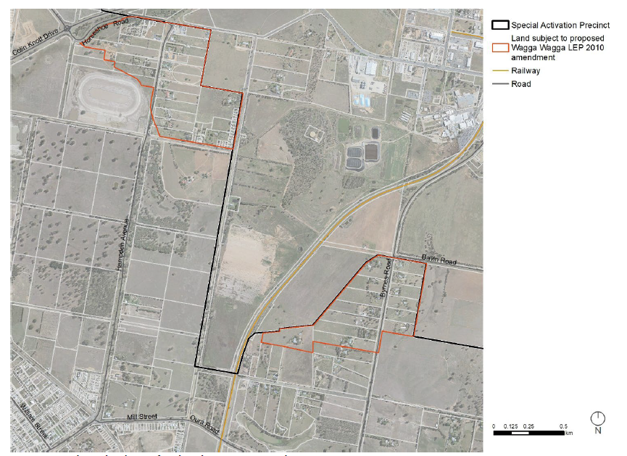

**1.3 Existing planning controls**

The subject lands are zoned R5 Large Lot Residential Zone (Cartwrights Hill) and RU4 Primary Production Small Lots Zone (North Wagga Wagga) (See Figure 2) (Note. Figure 2 includes adjoining lands proposed to change to Special Activation Precinct zones (Regional Enterprise and Rural Activity Zone) which do not form part of this planning proposal).

*Figure 2 - Existing and proposed zoning of subject lands (extract from planning proposal.*

*NB. Council has extracted the Proposed zoning map from the Wagga Wagga SAP Discussion Paper)*

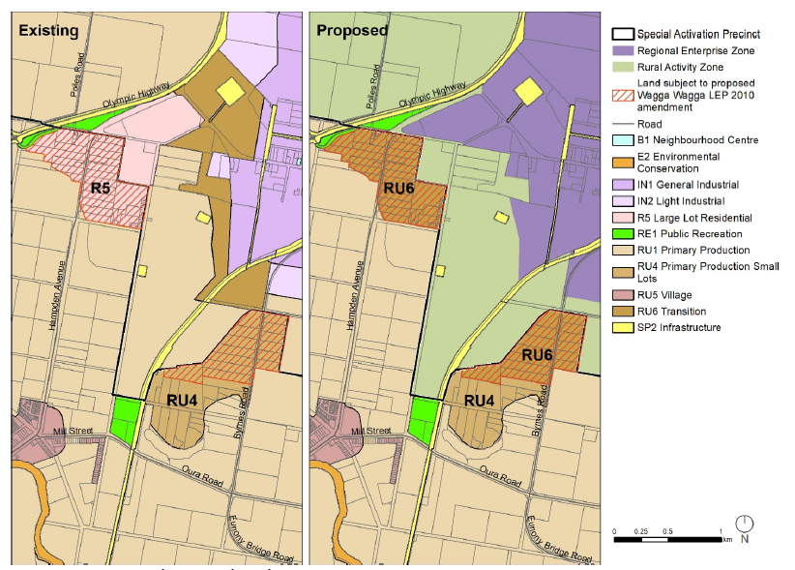

The subject lands have minimum lot sizes of 1ha (Cartwrights Hill) and 2ha (North Wagga Wagga) (See Figure 3 below).

*Figure 3 - Existing and proposed minimum lot sizes of subject lands*

*(extract from planning proposal)*

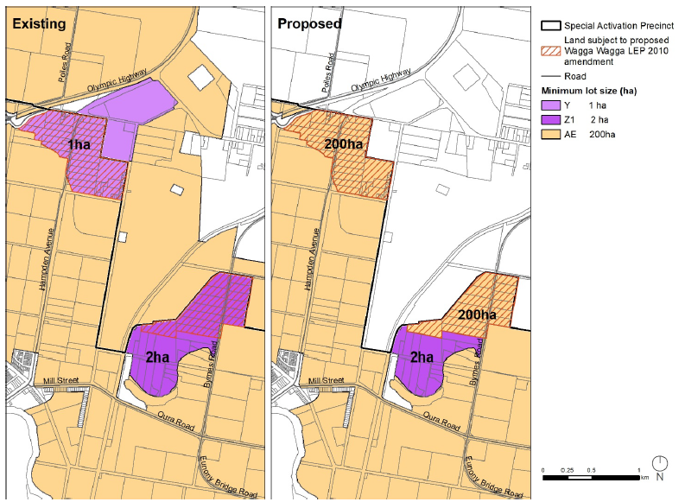

**1.4 Surrounding area**

The subject land consists of two precincts (Cartwrights Hill and North Wagga Wagga) – both are bounded by the Wagga Wagga Special Activation Precinct (SAP) to the north and east of each site. Both precincts are bounded on the remaining sides by rural floodplain (subject to high flood risk), as identified in Figure 4 below). The floodplain area is zoned RU1 with a 200ha lot size and is predominately used for agricultural purposes.

*Figure 4 – Flood risk precinct – Wagga Wagga Floodplain risk management plan*

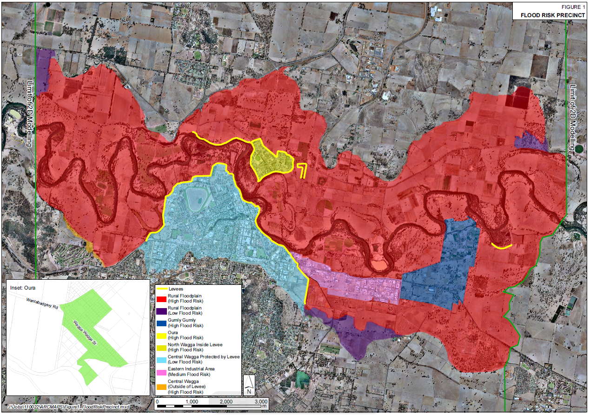

Subject sites

The subject land is north east of the City of Wagga Wagga and the Murrumbidgee River. To the north and east of the subject lands is the area known as the Bomen Business Park (now renamed to the Wagga Wagga SAP). The Wagga Wagga Special Activation Precinct (SAP) is an important economic growth area, supported by the NSW Government, which aims to reduce the cost and time of obtaining development consent for suitable businesses in the precinct (see Figure 5).

This area has been earmarked for significant industrial development for many decades. The business park already has significant industrial land uses near the subject lands, including a large abattoir and packaging plant owned by Teys, the second-largest meat-processor and exporter in Australia.

Technical studies undertaken to support the SAP, as well as other studies undertaken by Wagga Wagga City Council have identified areas that would be susceptible to noise and odour from the industrial area. The subject lands have both been identified as unsuitable for further residential development. This is discussed further in the report under section 3.

Figure 5 - Wagga Wagga Special Activation Precinct boundary (extract from planning proposal)

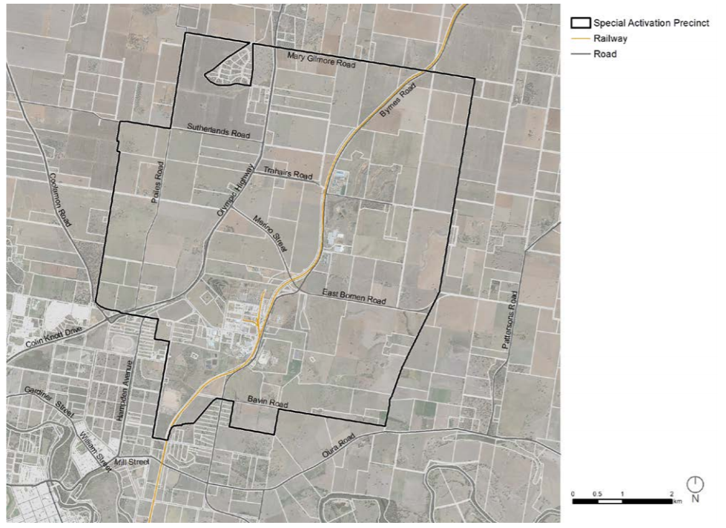

**1.5 Summary of recommendation**

*Proceed with condition*

The proposal to protect lands adjoining the SAP boundary from further residential development is supported, including the proposed zoning and minimum lot size changes.

However, it is recommended that part Lot 101 DP1095889, Byrnes Road, located inside the area impacted by the planning proposal, have a minimum lot size applied of 4ha. This is to allow the remainder of the lot outside the subject land boundary to be subdivided in accordance with its zoning and lot size provisions. An assessment is provided at section 5.1 of this report.

**2. PROPOSAL**

**2.1 Objectives or intended outcomes**

The objectives of the proposal are clear and do not require amendment prior to community consultation. The planning proposal states the objectives as:

*The objective of the planning proposal is to eliminate opportunities for additional residential development at the periphery of the Wagga Wagga Special Activation Precinct, to avoid exacerbating any potential land use conflict at this location in future.*

*In order to support the ongoing operation and success of the strategically important Wagga Wagga Special Activation Precinct, it is proposed to amend the planning controls for the areas…to prevent further intensification of residential uses on certain sites. This will be achieved through:*

*• ensuring that secondary dwellings will not be permissible on the subject lots; and*

*• preventing subdivision to [create] additional lots and dwellings.*

*The proposed amendments to the Wagga Wagga LEP 2010 for the subject land would maintain the rural landscape of these existing small residential clusters while preventing further intensification. The intent is to provide a balance between allowing existing residents to remain in the area whilst preventing further development for residential purposes.*

**2.2 Explanation of provisions**

The subject lands are proposed to be rezoned to RU6 Transition Zone (see Figure 2, page 2) and a 200ha lot size applied (see Figure 3, page 3). The LEP amendments as proposed in the planning proposal are clear. However, one additional change is required prior to community consultation.

Part Lot 101 DP1095889, Byrnes Road (also known as 59 Hillary Street) is recommended in this report (see section 5.1) to have a minimum lot size applied of 4ha. This is the area of the lot within the boundary of the subject land. Reducing the lot size will enable the remainder of the lot outside the subject land boundary to be subdivided in accordance with its zoning and lot size provisions to create up to 3 additional lots.

**2.3 Mapping**

The planning proposal will require amendment of the following Wagga Wagga LEP 2010 Map Sheets:

*Land Zoning Maps*

• LZN_003E

• LZN_003F

*Lot Size Maps*

• LSZ_003E

• LSZ_003F

Figures 2 and 3 show the current and proposed planning controls. The maps do not require updating prior to community consultation.

**3. NEED FOR THE PLANNING PROPOSAL**

Council’s planning proposal clearly articulates the need for the local environmental plan amendment. It notes that land within the Wagga Wagga SAP is of high strategic importance for the following reasons:

* *it is to become one of the largest employment hubs in Australia;*
* *it provides direct access to freight rail and to road networks supporting Higher Mass Limit road vehicles;*
* *it has large undeveloped and underdeveloped tracts of land, which provide opportunities for large industrial lots;*
* *it is home to cornerstone industrial enterprises including Teys, Heinz Watties, Austrak and Southern Oil Refining;*
* *it is located within a major regional centre, with the benefits that location offers to enterprise, but has a limited number of sensitive residential receptors in the immediate surrounds.*

The planning proposal identifies that the proposed amendments are needed to reduce the potential for additional sensitive land uses (ie. additional residential development) adjacent to the SAP area to avoid increased land use conflict.

Technical studies were undertaken by the NSW Government as part of the preparation of the Master Plan for the SAP. Todoroski Air Sciences undertook a report for the SAP Master Plan investigating planning considerations for air, noise and odour (dated 13 July 2020).

The Todoroski report concluded:

*In addition to the required minimum buffer area…, it is recommended to minimise or limit further residential intensification in areas close to the required buffer area. This is necessary to ensure that the projected impacts are not exacerbated in the future by residential creep (increased numbers of residential dwellings close to industrial sources).*

Council has used the findings of the Todoroski Air Services report, including Figure 6 below to inform the planning proposal outcomes. Figure 6 shows the Cartwrights Hill area (left) and the North Wagga Wagga area (right).

Figure 6 - Recommended buffer for minimising residential intensification

(extract from Todoroski Air Services Report)

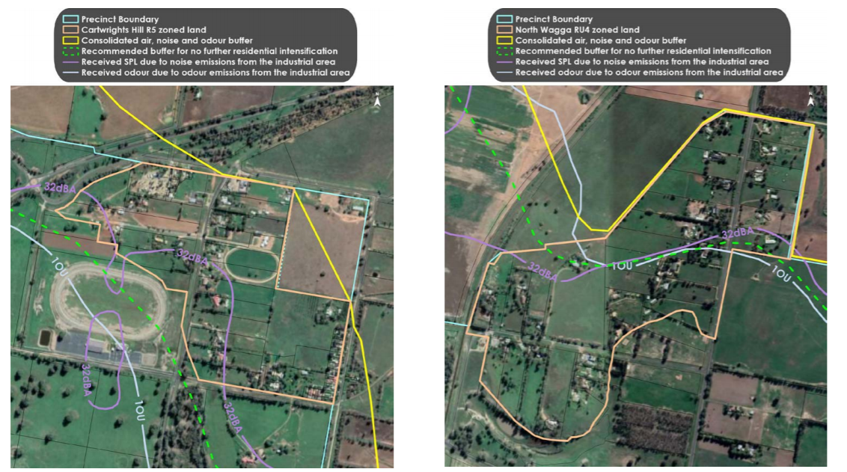

The *Wagga Wagga Local Environmental Plan 2010* includes clause 7.8 Cartwrights Hill Precinct – odour and noise assessment. This clause states that development consent must not be granted within the Cartwrights Hill Precinct unless the consent authority has considered the potential impacts of odour and noise from the Bomen industrial area and the Bomen sewage treatment facility. To date, Council has relied on clause 7.8 to extinguish any additional development opportunities in the Cartwrights Hill area. However, existing zoning and lot size provisions within Cartwrights Hill does not align with the strategic intent of the area. In addition, clause 7.8 does not expressly prohibit development and therefore does not provide the certainty that Council is seeking to ensure that further sensitive receptors are not placed near the SAP area.

As Clause 7.8 does not apply to the North Wagga Wagga site, there are currently no planning controls restricting development to protect the integrity of the adjoining SAP area. As identified above, the Todoroski report identified the North Wagga Wagga site as a sensitive receptor in which development intensification should be restricted. The planning proposal investigated a number of alternative methods (below) to provide certainty and ensure that further sensitive receptors are not placed near the SAP area.

Based on the technical studies undertaken, the importance of protecting the SAP and existing land uses within the Bomen industrial area, it is agreed that the planning proposal is needed to reduce the potential for further sensitive receptors in the subject lands.

Council’s planning proposal investigated other options for achieving the objectives. These included:

* Extending the application of Clause 7.8 of the *Wagga Wagga Local Environmental Plan 2010* to the North Wagga Wagga area, however this does not provide the desired level of certainty and alignment with the strategic intent of the planning controls applying to the site.
* Increase the minimum lot size (MLS) at Cartwrights Hill to 2ha or 5ha and to 5ha at North Wagga Wagga while retaining the existing zonings. While this would reduce the potential for any new lots to be created, it does not extinguish the ability for dual occupancies to be developed and the zoning would not align with the planning intent.
* Increase the MLS at both sites to 200ha while retaining the existing zonings, however secondary dwellings would still be permissible with consent and these areas would have lot sizes inconsistent with similarly zoned lands across the local government area. It would also be inconsistent with the zone objectives.
* Rezone the subject lands to RU6 but retain the existing MLSs, however this would still allow for further subdivision.

It is agreed that the proposal is the best means for achieving the intended outcomes as Council’s current clause 7.8 does not prohibit development in the subject lands and variations of zones and lot sizes would not satisfactorily achieve the desired outcomes of reducing potential for intensification in these areas. Changing both the land zoning and lot size more closely aligns the planning intent with the objectives of the planning proposal.

**4. STRATEGIC ASSESSMENT**

**4.1 State**

The proposal is not inconsistent with the State planning framework.

**4.2 Regional**

The planning proposal demonstrates consistency with the Riverina Murray Regional Plan. Specifically, it supports Action 4.3 *Protect industrial land, including in the regional cities (Bomen, Nexus and Tharbogang) from potential land use conflicts arising from inappropriate and incompatible surrounding land uses.*

The Regional Plan states that ongoing investment and development of the Bomen area will contribute significantly to jobs and economic growth. It notes that the encroachment of incompatible activities on industrial land will need to be managed. The outcomes of the planning proposal, to restrict additional residential development, will ensure that incompatible uses and activities on adjoining land will be avoided.

The planning proposal also demonstrates how the Special Activation Precinct implements and supports the following actions in the Regional Plan;

* Action 3.3 - Encourage co-location of related advanced and value-added manufacturing industries to maximise efficiency and infrastructure use, decrease supply chain costs, increase economies of scale and attract further investment.
  + Action 4.1 - Encourage the sustainable development of industrial land to maximise the use of infrastructure and connectivity to the existing freight network.
  + Action 4.2 - Promote specialised employment clusters and co-location of related employment generators in local plans.
  + Action 4.5 - Monitor the supply and demand of employment and industrial land in regional cities to inform the planning and coordination of utility infrastructure to support new development.

**4.3 Local**

The planning proposal is consistent with local strategies.

The *Wagga Wagga Spatial Plan 2013-2043* identifies the Bomen Business Park as a key area for the future development of the city. The planning proposal states that “*the proposed amendment to the Wagga Wagga LEP 2010 will preserve the full extent of development opportunities within the Wagga Wagga Special Activation precinct to support achieving this intent and therefore aligns with the Strategy.*” The Spatial Plan was endorsed by the Deputy Director General in 2014 without conditions.

The *Wagga Wagga Transport Strategy and Implementation Plan* (2017) includes a priority to establish Bomen as an intermodal hub connected to the Inland Rail Network, making the location of the SAP one of the most important freight and logistic destinations and hubs in Australia. The planning proposal states that “*one of the key actions of the plan requires the protection of the Bomen Business Park from inappropriate development and the prevention of land use conflict.*”

**4.4 Section 9.1 Ministerial Directions**

Council has identified there are no inconsistencies with the following Ministerial Directions:

* 1.1 Business and Industrial Zones
* 1.2 Rural Zones
* 1.5 Rural Lands
* 2.1 Environment Protection Zones
* 2.3 Heritage Conservation
* 2.4 Recreation Vehicle Areas
* 3.2 Caravan Parks and Manufactured Home Estates
* 3.3 Home Occupations
* 3.4 Integrating Land Use and Transport
* 4.3 Flood Prone Land
* 5.10 Implementation of Regional Plans
* 6.1 Approval and Referral Requirements

The assessment provided in the planning proposal is considered to be appropriate. The planning proposal has provided an assessment for each Direction, these have been clearly articulated and there are no inconsistencies with the above identified Directions.

Direction 3.1 Residential Zones

The proposal is inconsistent with Direction 3.1, as it contains provisions that will reduce the permissible density of land. However, the Direction states that a planning proposal may be inconsistent with the Direction if it is justified by a strategy or study or it is in accordance with the relevant Regional Strategy. As discussed in section 3 of this report, technical studies prepared as part of the Wagga Wagga SAP support the planning proposal and it also aligns with the Riverina Murray Regional Plan (Action 4.3) and Council’s Spatial Plan that was endorsed by the Deputy Director General of the Department. Both strategies aim to protect the Bomen industrial area (now the Wagga Wagga SAP), from potential land use conflicts and inappropriate land uses. Therefore, the inconsistency is justified in accordance with the terms of the Direction.

**4.5 State environmental planning policies (SEPPs)**

The planning proposal supports the intent and delivery of the *State Environmental Planning Policy (Activation Precincts) 2020*.

Whilst the SEPP (Activation Precincts) has not yet been made to reflect the changes in the Wagga SAP area, substantial progress has been made in the preparation of the draft instrument. The Department sought feedback from the community on the Wagga Wagga SAP draft master plan during public exhibition, which closed on 29 September 2020.

Accompanying the draft Master Plan is a Discussion Paper (Explanation of Intended Effect) that proposes the addition of the Wagga Wagga SAP to the State Environmental Planning Policy (Activation Precincts) 2020. Adding the Wagga Wagga SAP to the Activation Precincts SEPP would “turn off” the Wagga Wagga LEP for land within the Wagga Wagga SAP, meaning that the Activation Precincts SEPP will become the primary environmental planning instrument for that land.

The SEPP will establish new land use zones, new controls relating to Exempt, Complying and Designated Development and introduce some new streamlined development application processes for land within the Wagga Wagga Special Activation Precinct.

Council’s planning proposal states that it has considered all other SEPPs and no others are relevant to this proposal. It is agreed that no other SEPPs apply to this planning proposal.

**5. SITE-SPECIFIC ASSESSMENT**

**5.1 Social**

Council’s planning proposal places each of the affected lots into a category relating to perceived future development potential based on current zoning and MLS. Council notes that much of this potential would not be realised due to clause 7.8 in the Wagga Wagga Local Environmental Plan 2010.

Council established four categories in the analysis:

* lots that do not currently meet the MLS,
* lots that do meet the MLS (with or without a dwelling) but are not large enough to subdivide further,
* lots that have double the MLS and could potentially subdivide further, and
* one lot that meets more than the MLS and has a large portion of the lot outside the subject land, resulting in a split zone situation.

Council’s planning proposal removes the opportunity for further residential development potential, whether through the erection of a dwelling, a dual occupancy or subdivision for a dwelling.

Based on the analysis outlined above, the planning proposal estimates the area identified as Cartwrights Hill, could yield:

* Up to 19 additional dwelling lots;
* 1 existing vacant dwelling-sized lot;
* Up to 70 dual occupancy developments.

At the North Wagga Wagga area, it estimates the current zone and lot size provisions could yield:

* 1 additional dwelling lot;
* Up to 15 dual occupancy developments.

The analysis assumes that WWLEP Clause 7.8 is satisfied (which may not be achievable) and the use of clause 4.6 is used in some cases to vary development standards where lots overlap zone boundaries. Six of the above lots are currently owned by organisations and/or used for business purposes.

Council has resolved to remove the (perceived) residential development potential for the affected lots, as outlined in the planning proposal and summarised above. Whilst this is generally supported as achieving the objectives and intent of the planning proposal, Council was asked to clarify whether any of the savings provisions in clause 4.2A of the *Wagga Wagga LEP 2010* would allow the continuation of development opportunities on any of the affected lots. Council advised that 3 vacant lots and 3 lots currently used for non-residential purposes would retain dwelling opportunities under clause 4.2A(3). This advice is summarised in Table 1.

Table 1 - Applicability of Clause 4.2A(3) (Wagga Wagga LEP 2010) to various lots

|  |  |  |  |
| --- | --- | --- | --- |
| **Lot & DP** | **Street Address** | **Date created** | **Current land use** |
| Lot 5 DP 856275 | 126A East Street, Cartwrights Hill | 1995 | Vacant |
| Lot 11 DP 855048 | 39 Horseshoe Road, Cartwrights Hill | 1995 | Vacant |
| Lot 3 DP 247907 | 138 East Street, Cartwrights Hill | 1974 | Vacant |
| Lot 1 DP 623409 | 6 Old Bomens Road, Cartwrights Hill | 1982 | Commercial premises (Red Steer Hotel) |
| Lot 2 DP 623409 | 425 Hampden Ave, Cartwrights Hill | 1982 | Part of Red Steer Hotel (?) – converted service station |
| Lot 1 DP 161778 | Cooramin Street, Cartwrights Hill | 1956 | Country Women’s Association |

**It is recommended** that the Gateway determination include a condition that the planning proposal be updated to reflect the additional information provided by Council in relation to the applicability of clause 4.2A allowing the continuation of dwelling opportunities on some lots in the Cartwrights Hill precinct.

Lot 101 DP1095889 is 10ha in size. Approximately 4ha of the lot is located within the subject land and the remaining 6ha is located outside the subject land (see Figure 7). This results in the lot being split between the proposed RU6 Zone (with a 200ha MLS) and its current RU4 zone (with a 2ha MLS).

Figure 7 - Split Zone for Lot 101 DP 1095889, North Wagga Wagga (extract from planning proposal)

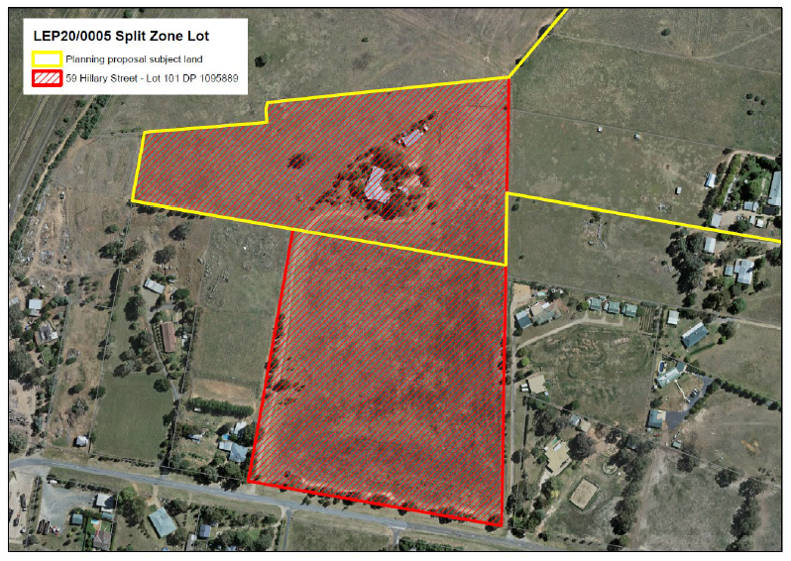

To subdivide land with an existing dwelling, each lot must maintain the MLS illustrated on the MLS map. In this case the northern part of Lot 101 DP1095889 would need to maintain a minimum lot size of 200ha. Council has indicated that it is not its intention to extinguish the development opportunities for this lot outside of the proposed RU6 Zone boundary. Therefore, **it is recommended** that the Gateway determination include a condition that the part of Lot 101 that is located within the subject land have a MLS of 4ha (instead of the proposed 200ha) to enable it to be subdivided from the remaining 6ha portion outside the subject land. This would retain the development opportunities on the portion of Lot 101 that is located outside the subject land boundary (ie. up to 3 additional lots). The Department has discussed this option with Council staff. It was agreed that it is the most appropriate option to ensure that the lots outside the planning proposal area are able to be subdivided.

Note: Clause 4.1A of the *Wagga Wagga Local Environmental Plan 2010* applies to lots with split zones that include at least one lot that is land in a residential, business or industrial zone. Unfortunately, the subject lot does not meet the criteria for clause 4.1A Exceptions to minimum subdivision lot sizes for certain split zones as both zones are rural.   
Additionally, Clause 4.6 Exceptions to development standards of the *Wagga Wagga Local Environmental Plan 2010,* is also unable to be utilised as the northern part of the lot would result in a lot that is less than 90% of the minimum area specified by the proposed MLS.

**5.2 Environmental**

There are no environmental impacts from the proposal as the rezoning and change in lot size will not result in any land use changes on the subject land.

# 5.3 Economic

The planning proposal discusses economic impacts on page 18 and 19. In summary the planning proposal seeks to avoid serious economic impacts to the city and region, by protecting the Wagga Wagga SAP area. As discussed above there has been significant investment into the Wagga Wagga SAP area in order to attract further investment and generate jobs for the Wagga Wagga region.

Avoiding the intensification of sensitive receptors adjoining the SAP area is necessary to preserve the success of the SAP. The planning proposal recognises the development potential of the land will be reduced however the value of the land will be retained to the extent that existing land uses have been established.

It is considered that whilst the landowners may experience an economic impact the economic benefit offered by the SAP is extremely important to Wagga Wagga and the wider region. Therefore, the rezoning and minimum lot size changes have been adequately justified, considering the broader economic benefits.

**5.4 Infrastructure**

There are no infrastructure impacts from the proposal as the rezoning and change in lot size will not result in any land use changes on the subject land.

**6. CONSULTATION**

**6.1 Community**

Council has indicated that consultation will be undertaken for this proposal (Part 5 and 6 of the planning proposal). Given the sensitive nature of this proposal, it is considered appropriate for Council to directly engage with all landowners impacted by the change of zoning and minimum lots size changes, in addition to the minimum 28 day requirements.

**6.2 Agencies**

Agency consultation is not considered necessary for this proposal.

**7. TIME FRAME**

Council’s planning proposal indicates a completion date of approximately 9 months. Given the sensitive nature associated with the delivery of the SAP and the amendments required the SEPP (Activation Precincts), it is considered more appropriate to issue a standard 6-month completion date.

**8. LOCAL PLAN-MAKING AUTHORITY**

Council has requested to be the local plan-making authority. Given the extensive strategic work to justify the rezoning as part of the Wagga Wagga SAP, the request is appropriate.

**9. CONCLUSION**

The planning proposal is appropriate to support, subject to community consultation and additional conditions to:

* clarify the applicability of clause 4.2A of the *Wagga Wagga LEP 2010* in retaining dwelling opportunities in the Cartwrights Hill precinct, and
* to address the unintended consequence of creating a split zoning over a property in North Wagga Wagga.

**10. RECOMMENDATION**

It is recommended that the delegate of the Secretary:

1. agree that the inconsistency with section 9.1 Directions 3.1 Residential Zones is justified.

It is recommended that the delegate of the Minister determine that the planning proposal should proceed subject to the following conditions:

1. The planning proposal should be made available for community consultation for a minimum of 28 days.
2. Council is to notify all landowners impacted by the change of zoning and minimum lots size changes in the planning proposal.
3. The time frame for completing the LEP is to be 6 months from the date of the Gateway determination.
4. Given the nature of the planning proposal, Council should be the local plan-making authority.
5. The planning proposal is to be amended prior to community consultation to reflect the applicability of clause 4.2A allowing the continuation of dwelling opportunities on some lots in the Cartwrights Hill precinct.
6. The planning proposal is to be amended prior to community consultation to apply a minimum lot size of 4ha (rather than the proposed 200ha) to the part of Lot 101 DP1095889 within the subject land in the North Wagga Wagga precinct.

**Haydon Murdoch Garry Hopkins**

**Team Leader, Western Region Director, Western Region**

**Local and Regional Planning**

Assessment officer: Meredith McIntyre

Senior Planner, Western Region

Phone: 6229 7912